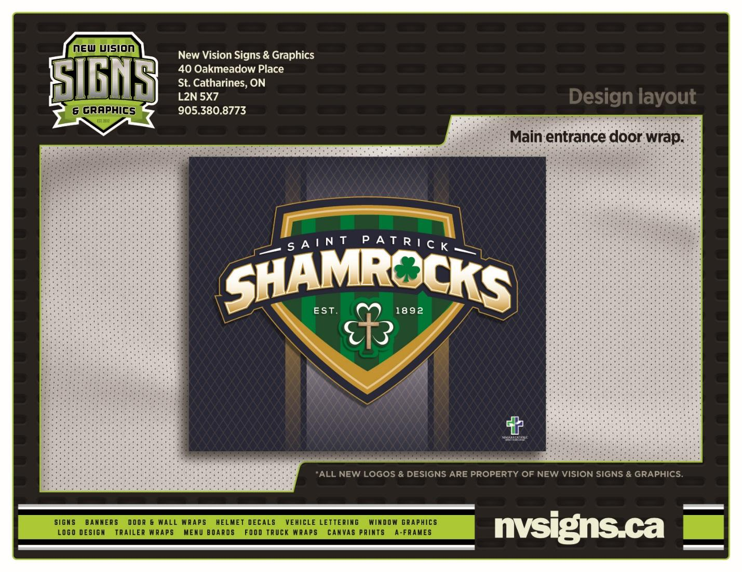

***St. Patrick Catholic School***

**4653 Victoria Ave., Niagara Falls, ON**

**Tel: (905) 354-6631**

**CATHOLIC SCHOOL COUNCIL MEETING AGENDA**

**DATE: Monday, September 27, 2021**



1. **ROUTINE MATTERS**

**1.** Land Acknowledgement and Opening Prayer – Mrs. Ricci

**2.** Roll Call

|  |  |  |  |  |
| --- | --- | --- | --- | --- |
| **Members** | **Affiliations** | Present | Excused | Absent |
| Trish McGilvery | Co-Chair | √ |  |  |
| Nancy Phillips | Co-Chair | √ |  |  |
| Mrs. Ricci | Treasurer- Principal | √ |  |  |
| Mrs. J.M. Villegas | Teacher Representative/Recording Secretary | √ |  |  |
| Mrs. A. Rombough | Non-Teaching Representative |  | x |  |
| Father Gerard | Parish Representative |  | x |  |
|  | Community Representative |  |  |  |
|  |  |  |  |  |
| **Parent Representatives** | | | | |
| Mrs. Phillips |  | √ |  |  |
| Mrs. McGilvery |  | √ |  |  |
| Mr. McGilvery |  | √ |  |  |
| Ms. Gold |  | √ |  |  |
| Mrs. Bell |  | √ |  |  |
| Mrs. Sawada |  |  |  | √ |
| Ms. Ladd |  | √ |  |  |
| Mrs. Aneesh |  | √ |  |  |
|  |  |  |  |  |

**3.** Approval of the Agenda

**4.** Disclosure of Interest

**5. *ELECTION*: CSC Chair** Mrs. McGilvery self nomination seconded by Mrs. Phillips

**CSC Co-Chair** Mrs. McGilvery nominated Mrs. Phillips; seconded by Mrs. Phillips

6. OAPCE Representative: Mrs. McGilvery accepted the position

7. Mrs. Ricci provided CSC members with a brief biography as this was the first time meeting the CSC as a group

1. **FAITH FORMATION**

**REPORTS FROM THE DIRECTOR’S MEETING**

1. Board Policy Approval Updates: N/A
2. Board Policy Vetting : N/A
3. **PRESENTATIONS – There are no presentations at the time.**
4. **BUSINESS ARISING FROM THE MINUTES OF THE MEETING**

* ***First CSC Meeting*:**

**Elections: Catholic School Council Co-Chairs**

1. **PRINCIPAL’S REPORT – Mrs. Ricci**
2. **STAFF REPORTS:** N/A
3. **NEW BUSINESS/QUESTIONS**

\****Fundraising***:

* Mom’s Pantry (Goal: December delivery)
* Big Red Meats (possibly twice; always successful)
* Pasta Night (February)

Truth and Reconciliation Day: September 30th

Snack Cart~ not possible at this time due to COVID 19 protocols as well as SchoolCash online goal

*Mrs. Ricci will investigate possibility of selling popcorn through SchoolCash online

Lunch Routine~ all students to stay on school premises during lunch

1. **NEXT MEETING – TBD**
2. **ADJOURNMENT 7:15pm**
3. **CLOSING PRAYER – Mrs. Ricci**